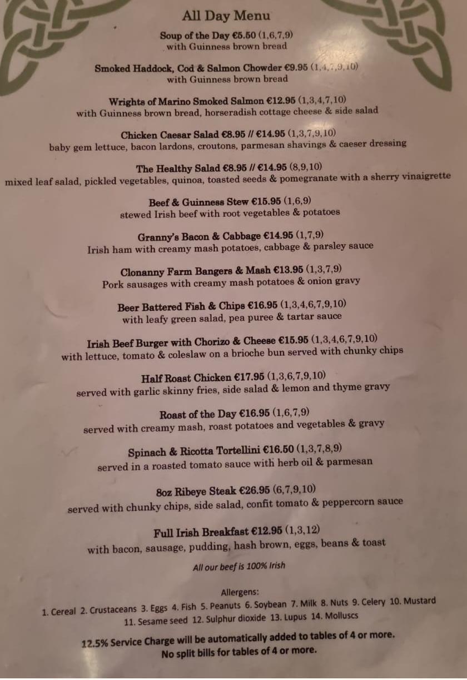
Menu from an Irish Pub (Dublin)

